
Procedural Map Generation
Using OpenGL

James Hopkins
University of South Wales

Abstract
This project is oriented around creating a tool that generates a procedural terrain. The project explored various procedural generation algorithms which were implemented with the intention of generating a smooth plane.
The proposed outcome of the project uses Perlin Noise to create a terrain and modify the x, y, and z values. Textures are applied and models are placed using OpenGL rending and shader methods.
The modelling software used in the demonstration is MagicaVoxel, a free to use voxel editor. This decision was made due to prior experience using the tool. Textures applied were either created using image manipulation software such as Microsoft’s Paint or Adobe’s Photoshop.
Table of Contents
0
Abstract 1
Table of Figures 3
1 Introduction 4
1.1 Background 4
1.2 Aim 5
1.3 Objectives 5
1.4 Deliverables 5
1.5 Time Plan for Meetings over the Course of the Year 6
1.6 Time plan for the project 7
2 Research 8
2.1.1 Requirement definitions 8
2.1.2 Functional Requirements 8
2.1.3 Non-functional Requirements 8
2.1.4 Legal, Ethical and Social Requirements 8
2.2 OpenGL 9
2.3 Programming Languages in use with OpenGL 10
2.3.1 C++ 10
2.3.2 Java 10
2.3.3 A Brief Comparison Between Java and C++ 11
2.3.4 Summary 11
2.6 Different Procedural Generation Algorithms 11
2.6.1 Perlin Noise 12
2.6.2 Simplex Noise 13
2.6.4 Diamond Square Algorithm 13
2.6.5 Midpoint Displacement Algorithm 14
2.6.4 Summary of the Algorithms 14
3 Design 15
3.1.1 Implementing the Perlin Noise Algorithm 15
3.1.2 Code 15
3.1.3 Result for Perlin Noise 17
3.2.1 Implementing the Diamond Square Algorithm 17
3.2.2 Result of Diamond Square 18
4 Conclusion 19
4.1.1 Objective 1 19
4.1.2 Objective 2 19
4.1.3 Objective 3 19
4.1.4 Objective 4 19
4.1.5 Objective 5 19
4.1.6 Objective 6 19
4.2 Further Improvements 20
Works Cited 21
Appendix I 22
STATEMENT OF ORIGINALITY 22
CS3D661 Individual Project 22
Appendix II - Ethics Checklist 23

Table of Figures
Figure 1 - No Man's Sky Procedural Creature 4
Figure 2 - An Example of OpenGL 9
Figure 3- One of the many weapons in Borderlands 11
Figure 4 - A demonstration of the grid points finding the gradient vector 12
Figure 5- An example of Minecraft's world building 12
Figure 6 -Simplex Noise Splices 13
Figure 7- A demonstration of the Terrain point inside a grid point 15
Figure 8- A terrain built using the Perlin Noise Implementation 17
Figure 9 - A terrain built using the Diamond Square Implementation 18
Figure 10- An example of two different terrains using Perlin Noise, but with different seed values 19

1 Introduction

1.1 Background
This research project is focused on the concept and implementation of procedural map generation within real time rendering. Procedural generation is the act of creating an object based on pseudorandom numbers. Applying this concept to a map allows for creators to have randomly generated maps, that appear natural and unique. For example, Mojang’s videogame, Minecraft, utilizes procedural generation techniques comprised of a modified version of the Perlin Noise algorithm, to create an open-world, sandbox experience that produces consistently different maps. Using the procedural methods allowed developers to create mountains, cave systems, grassy terrain, snow, sand and a plethora of other biomes with relative ease. One of the games primary features is the use of crafting materials found through digging, cutting down trees, mining underground and various other techniques available to the player in the virtual worlds. This was done through another Mojang used to distribute these crafting materials in a system that is fair and unpredictable for players, for example, a grove of trees is instantiated in close proximity to the player, so that wood can be found to aid in the players survival.
No Man’s Sky is an adventure, space exploration game developed by Hello Games. The game uses procedural generation techniques to create 18 quintillion unique planets. Other procedural techniques were used to randomly generate the creatures and the ships that inhabit the virtual universe. The planets all have different aspects ranging from different resources to mine, different trading posts and different types of creatures (some passive, some aggressive, some passive until threatened). However, with procedural generation comes the risk of creating something random that doesn’t very much make sense. For example, No Man’s Sky’s planets can be very repetitive as there are defined parameters that the planets are generated from and the creatures that are created can look aesthetically displeasing and illogical for the planet they reside upon.
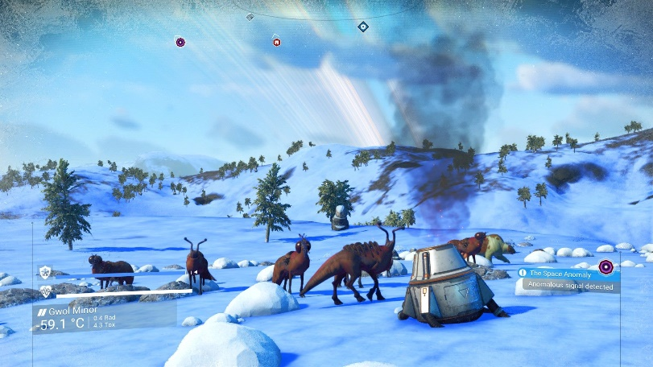
Figure 1 - No Man's Sky Procedural Creatures
For this project, a terrain will be procedurally generated to have a various size and shape. The users will have the ability to select models and textures they wish to be procedurally added to the terrain.
There are many ways to implement this system, a few algorithms that can be used are Perlin Noise, Diamond-Square and Midpoint Displacement.
A comparison between the different algorithms will be made and the most efficient and relevant system will be selected. The system in place must generate a terrain that provides a smooth landscape to allow for an aesthetically pleasing scene when placing models. The algorithm will produce the procedural terrain effect via use of seed numbers. A seed number is a string of data from which the selected algorithm can produce the desired random results. Depending on the algorithm, a seed may only produce one result, meaning an identical terrain could be generated using the same seed. This will ensure that each procedural terrain can be identified, so long as the seed remains the same.
The problems to be faced are:
- The terrain needs to be procedural but done so in a way so that the terrain grid points align accurately, thus creating a well-structured and connected map.
- The terrain must keep a record of the height value at each grid point to allow the placement of models on the terrain, not above or below.
- The terrain requires a texturing or colour aspect to allow the user to customize the generated terrain and produce more land-like results.
Should this project be successful, there will be a new tool that people may use for their projects to efficiently create scenes for different medias such as CGI green screen effects in movies and creating great scenery for video games.

1.2 Aim
The aim of this project is to develop a tool that is able to procedurally generate scenery using the Perlin Noise algorithm, the Diamond-Square algorithm and the Midpoint Displacement algorithm.

1.3 Objectives
- Develop a software that creates a set of vertices through the use of the Perlin noise algorithm.
- Modify the software created in Objective 1 to utilize the Diamond-Square algorithm and the Midpoint-Displacement algorithm.
- Use the software created in Objectives 1 and 2 to export the vertices as an image for use within frequently used game engines, such as the Unity3D engine, as a heightmap.
- Link the existing software’s functions to the OpenGL library and render the generated meshes within a 3D scene.
- Expand the software by applying a texture or colour to the generated mesh to provide it with the appearance of terrain.
- Further expand the software by utilizing a procedural algorithm to randomly instantiate a variety of models across the generated terrain.

1.4 Deliverables
The deliverables for this project will be this report, all source code that was used, a list of instructions detailing how to use the program. (that will also be in the program), and an executable file that will run the tool.

1.5 Time Plan for Meetings over the Course of the Year
The time plan is to accurately map out the meetings with Marius Miknis.
Task | Date/Time | Description
1st Meeting with Supervisor | 04/10/2018 | This meeting is to discuss how the project will be organised throughout the year
2nd Meeting with Supervisor | 11/10/2018 | This meeting is to discuss where to start with the project
3rd Meeting with Supervisor | 17/10/2018 | This meeting is to discuss what I would need to complete this project
4th Meeting with Supervisor | 24/10/2018 | This meeting is to discuss how to collect research for the project
5th Meeting with Supervisor | 01/11/2018 | This meeting is to discuss how to use the research in the report
6th Meeting with Supervisor | 08/11/2018 | This meeting is to discuss how to use the research in the report
7th Meeting with Supervisor | 15/11/2018 | This meeting is to discuss what the report should entail and how it should be presented
8th Meeting with Supervisor | 22/11/2018 | This meeting is to discuss how the report is going for the first milestone
Milestone 1 | 23/11/2018 | This milestone is a small check-up to see how I’m getting on with the project
9th Meeting with Supervisor | 29/11/2018 | This meeting is to discuss what is needed for the design portion of the report
10th Meeting with Supervisor | 06/12/2018 | This meeting is to discuss what is needed for the design portion of the report
11th Meeting with Supervisor | 13/12/2018 | This meeting is to obtain and discuss Milestone 1 feedback
Milestone 1 Results Deadline | 14/12/2018 | This deadline is to obtain Milestone 1 feedback
12th Meeting with Supervisor | 10/01/2019 | This meeting is to discuss additions and modifications made before Term 1 ended.
13th Meeting with Supervisor | 17/01/2019 | This meeting is to discuss an implementation method and how to proceed
14th Meeting with Supervisor | 24/01/2019 | This meeting is to discuss any errors in the previously mentioned implementation method
15th Meeting with Supervisor | 31/01/2019 | This meeting is to discuss Milestone 2 prior to the submission date
Milestone 2 | 01/02/2019 | This milestone is to check if the project is going the way it is intended to and to see if the report makes sense in the wording
16th Meeting with Supervisor | 07/02/2019 | This meeting is to discuss an implementation method and how to proceed
17th Meeting with Supervisor | 14/02/2019 | This meeting is to discuss an implementation method and how to proceed
18th Meeting with Supervisor | 21/02/2019
19th Meeting with Supervisor | 28/02/2019
Milestone 2 Results Deadline | 01/03/2019 | This deadline is to obtain Milestone 2 feedback
20th Meeting with Supervisor | 07/03/2019
21st Meeting with Supervisor | 14/03/2019
22nd Meeting with Supervisor | 21/03/2019
23rd Meeting with Supervisor | 28/03/2019
Milestone 3 | 29/03/2019 | This milestone is to submit the completed project (code, report, anything additional)

1.6 Time plan for the project
The planning for this project is oriented towards researching various algorithms in the first 3 months. In the new year, implementation of the algorithms will begin.

2 Research

2.1.1 Requirement definitions
This section outlines the requirements of the project.
The project is written in C++, a language that was selected due to the high quantity of standard coding libraries and a large amount of documentation. Libraries such as the GLFW library, an open-source OpenGL library, can be added to a C++ project or solution with relative ease. The compilation and debugging of the project were conducted in Microsoft’s Integrated Development Environment (IDE), Visual Studio 2017. The IDE has in-depth memory and code debugging options which are much more extensive than other comparable IDE’s such as Netbeans or Eclipse. The modelling software utilized for this project is a free-to-use tool, MagicaVoxel. The software allows the user to create and export models, constructed out of voxels.

2.1.2 Functional Requirements
The functional requirements of this project are as follows:
- Successfully compile a list of the users’ models and textures, checking to see if they are loaded correctly
- Create a list of values that contain x, y, and z coordinates
- Increment the x and z values until reaching the requested height and width of the terrain plane. During this stage, modify the y value to provide a procedural value.
- Apply textures to further customise the terrain, allowing the user to more accurately visualise the map.
- Render the terrain.
- Add models to the terrain that match the layout of the map, E.g. placing trees and cacti in a desert area, or buildings and roads on a city area of the map

2.1.3 Non-functional Requirements
The non-functional requirements are as follows:
- The user must know how to use the program. The program itself will have basic instructions but there will also be a user manual to further indicate what each section of the program does
- The program itself may require a dedicated graphics processing unity (GPU) in order to run through the various calculations without a drop in frames per second (FPS).

2.1.4 Legal, Ethical and Social Requirements
All libraries that I will use will be referenced and are free to use.
The program I am creating will be made from scratch, no prior code will be used.
For ethical reasons, the code must be kept professional. In 2011, when the videogame Dead Island was originally released, Steam users browsed through the source files and discovered a skill called with an inappropriate name. Although likely intended as a joke amongst the developers, this code sparked an uproar from the player base and created a large controversy around the topic (Purchese, R. (2011)).

2.2 OpenGL
As Sigel and Akeley define, OpenGL is an API (Application Programming Interface) that is used for its functions that can implement graphics in programming. Silicon Graphics Inc started development of OpenGL in 1991 and released it’s first version June 30th, 1992.
OpenGL is written for use with C based languages but can also be used with Java (using LWJGL – The Lightweight Java Game Library) and Python (using PyOpenGL) with the correct extensions. OpenGL contains hundreds of functions built in for developers and engineers to create 3D graphics for use in media, such as films or video games.
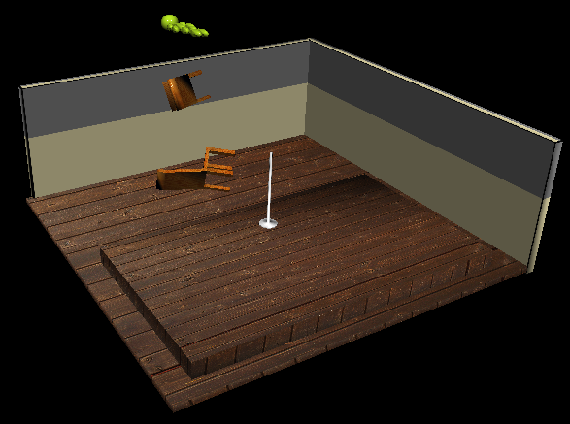
Figure 2 - An Example of OpenGL
As OpenGL is open-source, it is easily obtainable due to the internet and with the amount of document available for it, it is easy to pick up and learn. tea
There are many functions that come with OpenGL, a few of them are:
- glBegin(rendering mode); and glEnd(); - glBegin specifies the current rendering mode and starts a vertex list which, when added to the list, the vertices are converted to this mode.
  - For example, some rendering modes include, GL_POINTS, GL_LINES, and GL_TRIANGLE_STRIP
- glVertex – This command adds a vertex to the vertex list along with a pair of coordinates, (x, y).
- glColor – gives the vertex in the vertex list a colour to abide by.
- glEnable and glDisable – enables and disables blending for rendering results to combine.
- glUseProgram() – Enables use of shader programs in the code that follows.
OpenGL uses shaders to render selected graphics on the Graphics Processing Unit, rather than the Central Processing Unit. Shaders allow the customisation of graphics. The graphics can be altered using vertex shaders, which takes information such as position, colours, indices, etc. Each vertex is then rendered in a series to a block of memory to be sent to the output. A fragment shader processes a fragment that is generated by broken down elements into a series of colours and a depth value. The fragment shader takes one fragment input and produces one fragment for output.
Shaders take input from the objects and customises the output for the next stage in the rendering pipeline.
There are several alternatives to OpenGL, one of them is DirectX. DirectX is also an Application Programming Interface that creates graphics and other multimedia effects, such as audio management. DirectX is owned by Microsoft, which does mean a restriction on compatibility as DirectX can only be used with Microsoft’s Windows. A program written in DirectX may not work in Linux, but OpenGL can run if it has 3D acceleration.
In a report released by renowned Video Game Developer company Valve (Anthony, 2012), they tested one of their games (Left 4 Dead 2) using DirectX and OpenGL. In the report they discovered that DirectX maxed out at 270.6 frames per second and OpenGL maxed out at 315 Frames Per Seconds. For this result, OpenGL is seen to have a much smoother and efficient rendering pipeline. DirectX renders a frame in 3.69 milliseconds based on the 270.6 fps, whereas OpenGL renders a frame in 3.29 milliseconds based on the 303.4 frames per second recorded.
I will use OpenGL as the basis for my project as I have more experience in OpenGL than any other graphics API.

2.3 Programming Languages in use with OpenGL

2.3.1 C++
C++ was developed by Bjarne Stroustrup in 1979 for his PHD project and is one of the oldest languages in common usage, ranking 4th in popularity according to 2016 IEEE spectrum Top Programming Language Ranking. The language is typically used for object orientated programming and was created because Stroustrup “felt that no existing language was ideal for large scale projects.” Today C++ is used in games, operating systems, browsers and more due to it being a “sophisticated, efficient and a general-purpose programming language “
C++ has various benefits over using other programming languages. One of the key advantages is that it is one of the most efficient languages out there, often used in resource intensive programs. There are a variety of uses, from Graphical User Interfaces to 3D graphics for video games (Like the OpenGL API).
Lots of libraries are out there for C++ that make it a massive language that can provide any user a solution to most problems. Iostream is a common class used by C++ programmers as it is an Input/output library used to collect user input and display additional information on a console. A library for vectors is also used in C++ as C++ is an object oriented programming language, it’s a useful type of list that has several commands that can be used to modify the vector. Such as push_back() which is used to add a value into the vector, and pop_back() which removes the last element in the vector.

2.3.2 Java
Java was developed in the early 90s by a team led by James Gosling for Sun Microsystems (an American company that sold computer components, developed software and general Information Technology services that is now owned by Oracle).
Java was made to combat C++’s complex syntax and provide a powerful language that was easy to use. Java also includes a high level of security as it was initially designed for mobile platforms. Speaking of platforms, this language was written to work without complications regardless of the device, making it a powerful and portable tool to use. With all this in mind, Java is incredibly reliable, becoming incredibly robust when Object Oriented Programming was also included in the project.
Java includes a set of standard libraries which contain hundreds of commands to be used for the ease of the user. For example, java.lang is a fundamental library as it contains classes for String, Math, Double, etc. java.util is used for data structures, java.io is used for input/output files. A library available to Java is LWJGL (Lightweight Java Game Library) which allows for the development of OpenGL, Vulkan, OpenAL and OpenCV applications whilst also providing high performance access with a sleek, user friendly interface.

2.3.3 A Brief Comparison Between Java and C++
As is discussed by Tripathi, C++ is generally faster than Java, with or without using OpenGL as when compiling a Java program, all the classes that are involved need to be loaded first for the program to compile. However, by picking any of these languages there won’t be any noticeable drops in performance, as they are both efficient languages. Documentation for OpenGL in C++ is more accessible than OpenGL in Java.

2.3.4 Summary
Due to a lack of experience with Java, C++ is the only candidate for this project.

2.6 Different Procedural Generation Algorithms
Procedural generation is the method of creating content using algorithms than creating content manually. Procedural generation is used in many video games to provide an element of randomness and innovation. In the game series Borderlands procedural generation is used to create weapons in the game, a well-received mechanic that added much more of a variety to the gameplay, like fire elemental effects on a sniper rifle, or a shotgun which shoots in rapid succession.
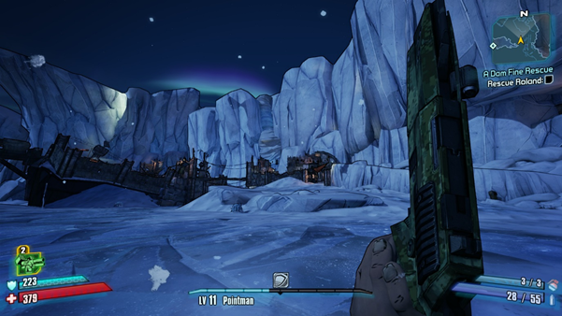
Figure 3- One of the many weapons in Borderlands
This could create a new environment for players in video games, or in film it could create lush scenery to be used in green screen effects.
For my project, I need to find an algorithm that can create a terrain plane with a smooth transition (e.g. like a wave effect) instead of having a flat plane. Having a map with variances in height provides a level of innovation, immersion, and replicates a terrain more accurately.

2.6.1 Perlin Noise
Perlin noise lays out a grid where the lines are x and y values. Each point in the grid has a random gradient vector pointing in a random direction. Each pixel takes the neighbouring grid points and the gradient vector. Each neighbouring point takes the dot product of the gradients with the difference (pixel – neighbouring grid point), and the dot product contributes to the noise value for the pixel.
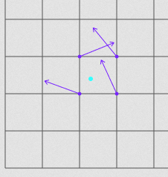
Figure 4 - A demonstration of the grid points finding the gradient vector

For content generation, the Perlin noise algorithm is commonly used. This algorithm was created by Ken Perlin back in 1983 as he wasn’t happy with the machine like look of computer graphics.
Perlin created this algorithm whilst working on the movie Tron, he used it to apply generated textures for computer generated graphics. For his work on this algorithm, he won an Academy Award for Technical Achievement in 1997.
The algorithm itself provides a more organic appearance than using pseudo random numbers. It can be used to create wave effects in textures or undulating materials. A modified version of the Perlin Noise Algorithm was used to create vastly popular procedurally generated maps in the game Minecraft.
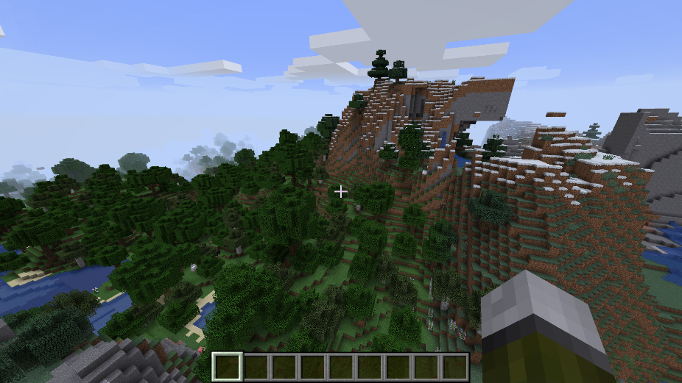
Figure 5- An example of Minecraft's world building

2.6.2 Simplex Noise
Simplex noise is a derivation of Perlin Noise, others refer this as using a simplex grid with a falloff function to compute gradient noise. The different aspects that it compares to Perlin Noise are that while in N-Dimensional space context, the computational complexity of Perlin Noise is O(2^{N}), whereas Simplex Noise only uses O(N) which reduces the computational complexity, it transforms the complex multiplication into summation operations, which in hand reduces the computational costs greatly. There is a fundamental problem of classic noise which is that it involves sequential interpolations alongside each dimension.
This algorithm was designed and patented in 2001 by Ken Perlin. Simplex noise divides spice into simplices, an example of this would be n-dimensional triangles. This can be interpreted in many ways, like in 1D, it would be interpreted as a line, in 2D it would be as a triangle instead as a regular square, for 3D it is a tetrahedron instead of a cube, and 4D is a pentatope instead of a tesseract, but these can all be skewed to be a chosen shape. Throughout calculations it means that you consider n dimensions you only consider 1+ n points instead of 2^{n}.
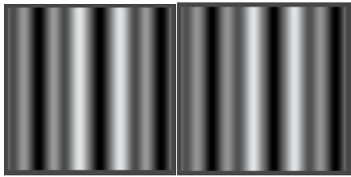
Figure 6 -Simplex Noise Splices
These are put within simplex grids which translates to for a space within N dimensions, pick the simplest and compact shape that can be repeated so that it can fill the entire space.

2.6.4 Diamond Square Algorithm
The Diamond Square algorithm uses 4 procedural corner values of an array to fill the terrain with midpoint displacement values. DS requires an array of 2^n+1 in width and in height. Diamond Square uses already calculated values to fill the array.
With the array of 2^n+1, diamond square sets the corner values, proceeds to take the four corner values, averages them and adds a random value to the average, creating a diamond shape. This is the diamond step. The square step consists of averaging the diamond shape created during the diamond step. The centre of that shape becomes the corners of the next step. This is repeated until all the points have values assigned to them.

2.6.5 Midpoint Displacement Algorithm
The Midpoint Displacement Algorithm may be the easiest of the algorithms. Midpoint Displacement generates a terrain heightmap using the height values of the four corners of the terrain. The terrain is then subdivided into small rectangles, and the height values of the small rectangles are the average value between the corners of the terrain.
The algorithm is split into 4 tasks:
- Initialize the four corners of the plane with random values
- The midpoints of each edge is set to the average of the two corners, with the addition of a random value
- The centre of the plane is set to the average of the midpoints from the previous step, with the addition of a random value
- Repeat for each line created until the algorithm reaches the correct level of detail

2.6.4 Summary of the Algorithms
The Perlin Noise algorithm provides quick and efficient coordinates for the plane. These coordinates will create a nice smooth wave effect so that models can be placed onto it with ease, if that is what is required.
The program I am implementing will do the following:
- Calculate the noise for the coordinates of the terrain plane.
- Calculate the indices for the terrain plane
- Bind the vertex array and indices vector to a Vertex Array Object
- Use OpenGL rendering modes to display the map

3 Design
This section will focus on the implementation of the noise algorithm. To implement the program, I will be using Visual Studio.

3.1.1 Implementing the Perlin Noise Algorithm
The Perlin Noise algorithm itself is to be implemented as a class. The algorithm will create a permutation vector filled with random integers. For each coordinate in the terrain plane the x and y coordinate is passed into the Perlin Noise class, there it is used to find the grid point that contains the terrain point (Named X, Y, Z to separate from x, y, z). The x, y, and z coordinates of the grid point are then used to find the other relative x, y, and z terrain point inside the grid point.
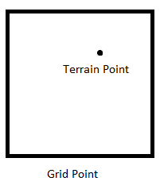
Figure 7- A demonstration of the Terrain point inside a grid point
Once the grid and terrain point have been acquired, the x, y, and z of the terrain point is given a fade curve. Without the fade curve, the terrain becomes very fluctuant and isn’t a smooth wave.
To blend the results from the corners of the grid point, hashing needs to happen to the coordinates. The hashed coordinates will be in 6 separate variables; A, AA, AB, B, BB and BA.
With the freshly hashed variables, a lerp function is used to blend the results together. Lerping is the act of linear interpolation, which is to get from a to b via c.

3.1.2 Code
The code below is a version of Ken Perlin’s noise algorithm but in C++. Firstly, a permutation vector had to be created. The vector itself is the size of the terrain height and width, which is then multiplied by 4. The reason behind this is to provide a large variety of terrain shapes.
//creates pseudo random numbers
default_random_engine DRE(seed);

//Fills the permutation vector with the new random numbers
shuffle(Perm.begin(), Perm.end(), DRE);
Perm.insert(Perm.end(), Perm.begin(), Perm.end());
The vector itself is the size of the terrain height times the terrain width. The reason behind this is to provide a large variety of terrain shapes. The permutation vector is then filled with the value of 0. Using a default_random_engine, the seed generates random values for the permutation vector, stored in DRE. The random values from DRE are then shuffled into the vector and then at the end of the vector, the values are duplicated. This is how the permutation vector is made.
//takes the decimal and rounds it down to the next whole number
int X = (int)floor(x) & 255;
int Y = (int)floor(y) & 255;
int Z = (int)floor(z) & 255;

x -= floor(x);
y -= floor(y);
z -= floor(z);

The x, y, and z coordinates of the terrain point are rounded down to whole numbers to find the grid point. The fade curve function provides a smoother transition between gradients.

int A = Perm[X] + Y;
int AA = Perm[A] + Z;
int AB = Perm[A + 1] + Z;
int B = Perm[X + 1] + Y;
int BA = Perm[B] + Z;
int BB = Perm[B + 1] + Z;

The coordinates that are hashed are stored in integer variables.
double BlendedResults = Lerp(w, Lerp(
v, Lerp(u, Gradient(Perm[AA], x, y, z), Gradient(Perm[BA], x - 1, y, z)), Lerp(u, Gradient(Perm[AB], x, y - 1, z), Gradient(Perm[BB], x - 1, y - 1, z))), Lerp(v, Lerp(u, Gradient(Perm[AA + 1], x, y, z - 1), Gradient(Perm[BA + 1], x - 1, y, z - 1)), Lerp(u, Gradient(Perm[AB + 1], x, y - 1, z - 1), Gradient(Perm[BB + 1], x - 1, y - 1, z - 1))));
return (BlendedResults + 1.0) / 2.0;

The gradient functions return the dot product between a random gradient vector from the terrain point to the 8 surrounding points in the grid point. The gradient functions are lerped together to form a final dot product result for the grid point.

int h = hash & 15;
double u = h < 8 ? x : y,
v = h < 4 ? y : h == 12 || h == 14 ? x : z;

return ((h & 1) == 0 ? u : -u) + ((h & 2) == 0 ? v : -v);

The gradient function takes the hashed coordinate and use only the first 4 bits. If the significance of the hash is 0 then double u is set to x, if not then double u is set to y. Double v is set to y if the first and second bits are 0, if the first and second bits are 1 then double v is set to x, if the first and second bits don’t match then double v is set to z.
The returning value is the addition of double u and double v.

3.1.3 Result for Perlin Noise
The terrain looks excellent. It looks very smooth and suitable for the placement of models and terrain. This also didn’t take long to render, taking less than a second to render.
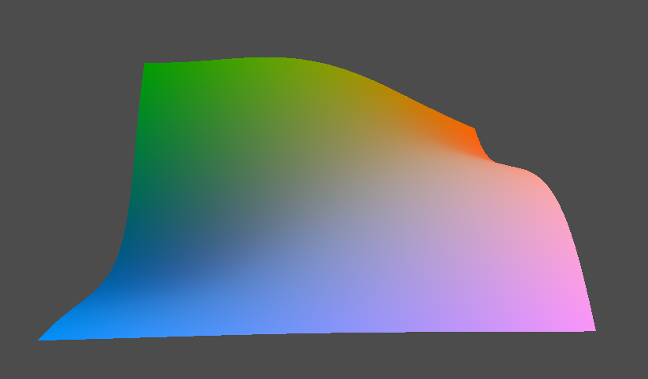
Figure 8- A terrain built using the Perlin Noise Implementation

3.2.1 Implementing the Diamond Square Algorithm
The diamond square algorithm is implemented as a set of functions. The functions will alter a 2D array whose size is determined by TerrainHeight and TerrainWidth. As Diamond Square requires the 2D array to be 2^n+1, the array is DiamondArray[TerrainWidth+1][TerrainHeight+1];
A variable containing the size of the terrain is set before each iteration of the function. This variable is checked to see if the value is greater than 1, if it isn’t then the function returns.
A nested for loop is implemented that takes the terrain and traverses through only half. Inside that for loop the SquareStep function is called. This function takes the modulus of the nested for loop iteration and terrainHeight, the for loop iteration and terrainWidth, and the variable of the terrain size.
for (int i = half; i < TerrainHeight; i += Terrsize)
for (int j = half; j < TerrainWidth; j += Terrsize)
SquareStep(j % TerrainHeight, i % TerrainWidth, half);
Inside the SquareStep function there are various IF statements, a float variable for the average, and an increment counter. The condition of each statement tests the value of x and z, and depending on which if statement is true, adds the value of DiamondArray[x][z] to the float variable for the average. This also increments the counter value by 1.
if (x + half < TerrainWidth && z + half < TerrainHeight);
{
average += DiamondArray[x + half][z + half];
count++;
}
average += rand() % half + 1;
average /= count;
DiamondArray[x][z] = round(average);
The average float has a random value added to it ranging from 1 to the size of the terrain and is then divided by the count. The average variable is then added back to DiamondArray[x][z].
Another for loop is implemented for the other half of the terrain. An integer keeps track of the column number. An IF statement determines if the column is even or odd. If the column number is odd, a nested for loop runs from the terrain size variable set earlier until it reaches the TerrainWidth variable. The DiamondStep function is inside this for loop and takes the modulus of the nested for loop iteration and terrainHeight, the for loop iteration and terrainWidth, and the variable of the terrain size. If the column is even, the nested for loop runs from 0 to TerrainWidth, sending the same arguments into the DiamondStep function.
Columns++;
if (Columns % 2 == 1)
for (int j = half; j < TerrainWidth; j += half)
DiamondStep(j % TerrainHeight, i % TerrainWidth, half);
else
for (int j = 0; j < TerrainWidth; j += half)
DiamondStep(j % TerrainHeight, i % TerrainWidth, half);

Inside the DiamondStep function there are various IF statements. Like the SquareStep, the condition of each statement tests the value of x and z to see how it compares to the TerrainHeight and TerrainWidth, and depending on which if statement is true, adds the value of DiamondArray[x][z] to a float variable for the average.
if (z + half < TerrainWidth);
{
average += DiamondArray[x][z + half];
count++;
}
average += rand() % half + 1;
average /= count;
DiamondArray[x][z] = (int)average;

At the bottom of the DiamondSquare function, the terrain size variable is halved and then the DiamondSquare function calls itself. This way the function keeps running until the terrain size variable is less than 1.

3.2.2 Result of Diamond Square
This implementation does not seem to be working quite as well as the Perlin Noise algorithm. The terrain takes a few coordinates and fluctuates them wildly.
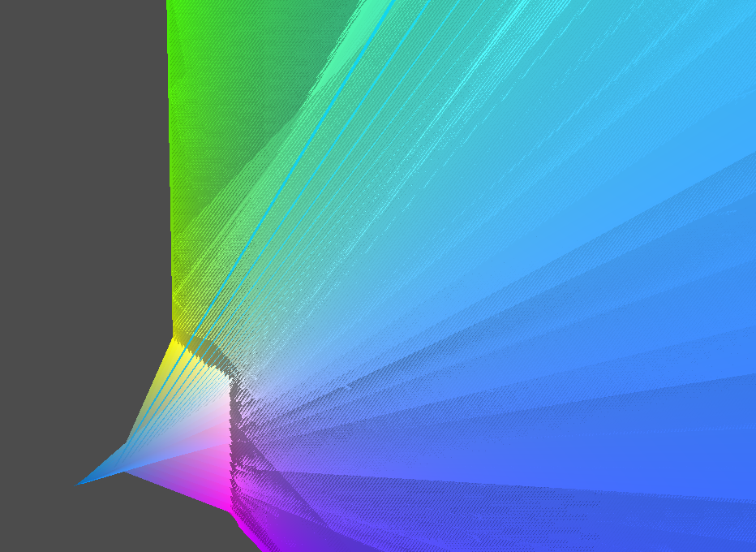
Figure 9 - A terrain built using the Diamond Square Implementation

4 Conclusion
The aim of this project was to create a tool that in turn, creates a terrain with procedural values. The testers of this program found that the terrain was displayed in a very informative way. They noted that as the project only switches between two algorithms, there wasn’t much to speculate.
Most of the initial objectives were completed. Objectives 1, 2, 4, and 5 were implemented while 3, and 6 were not.

4.1.1 Objective 1
Objective 1 created the Perlin Noise algorithm successfully and allowed the user to generate a new procedural terrain every time the F key was pressed. This objective also provided the foundation for the rest of the project, as it also included code that modified the terrain.
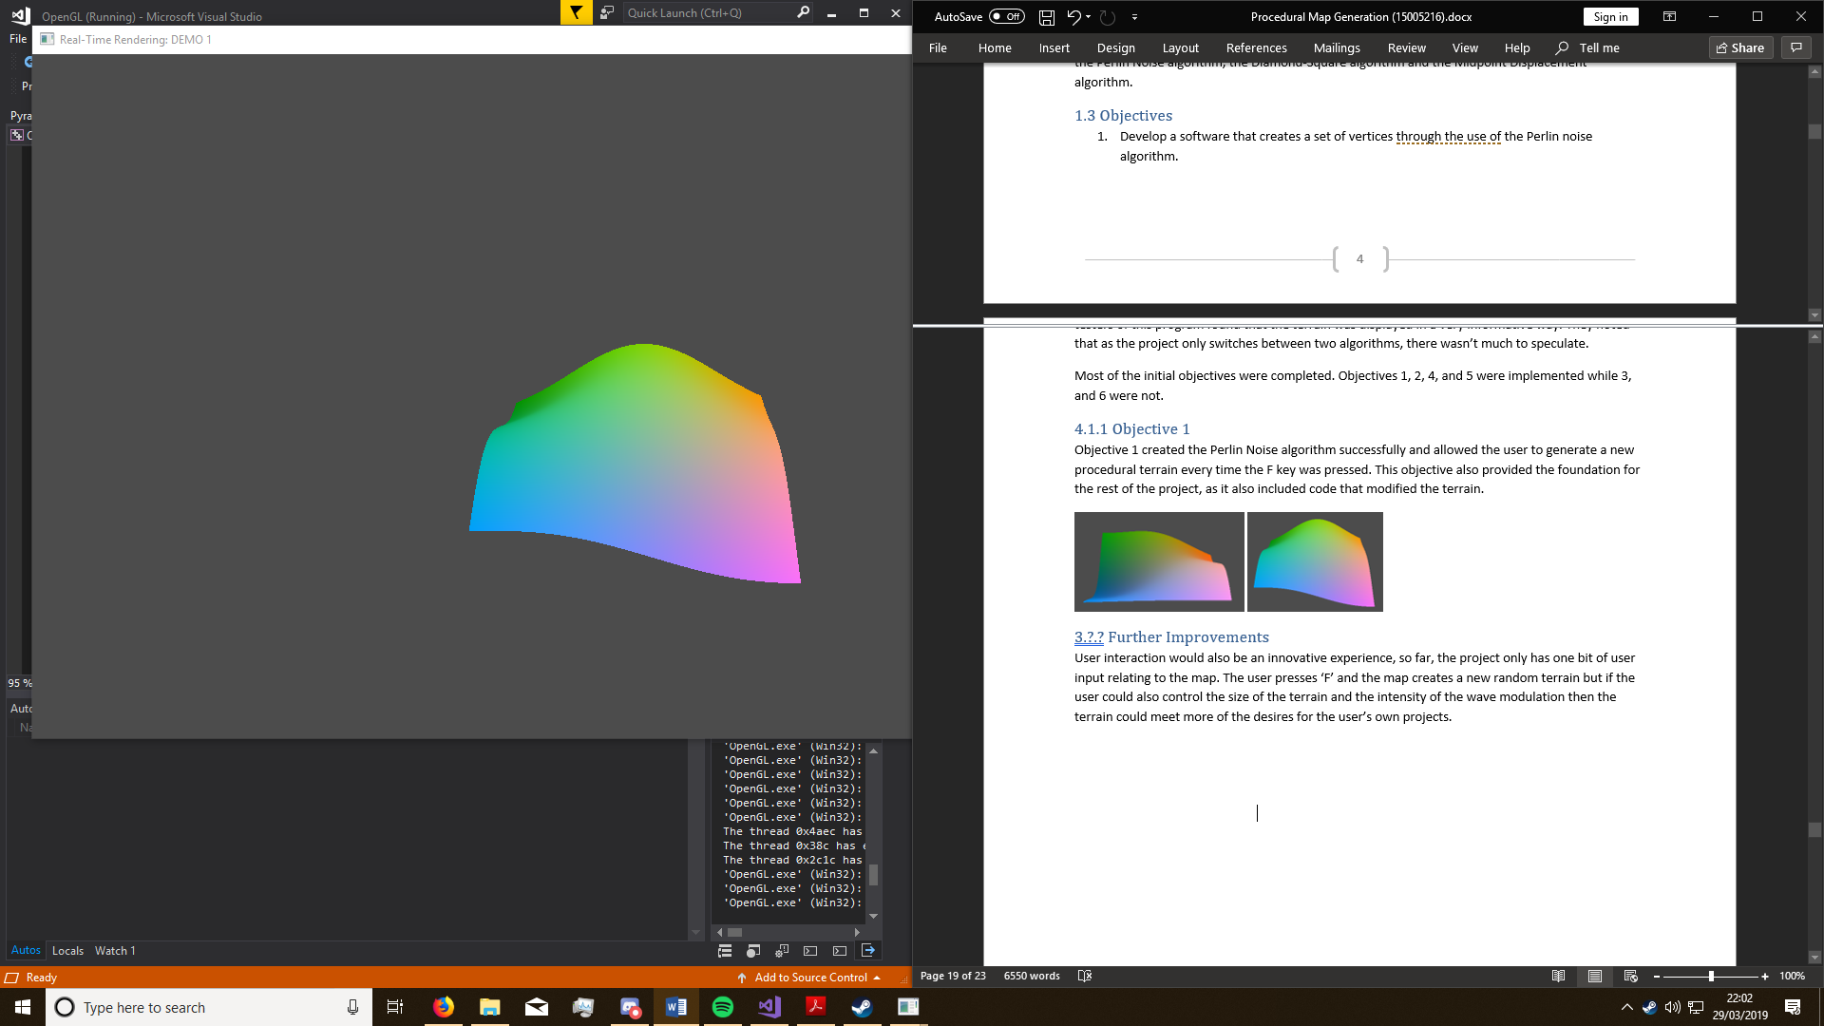
Figure 10- An example of two different terrains using Perlin Noise, but with different seed values

4.1.2 Objective 2
Objective 2 was related to implementing a diamond square and a midpoint displacement algorithm system, however this was not implemented entirely. The Diamond Square implementation failed to work, leaving the terrain unacceptable. The Midpoint Displacement system also wasn’t implemented due to a lack of time.

4.1.3 Objective 3
Objective 3 meant to export the terrain data onto an image file as that data can be converted using Unity3D into a heightmap. Ultimately, this wasn’t implemented.

4.1.4 Objective 4
Objective 4 was implemented successfully; the OpenGL library was used as the terrain object was stored inside a VAO. The VAO stored vertices, indices and colour data for the terrain, using the VAO to be placed on screen.

4.1.5 Objective 5
Objective 5 was partially implemented. The terrain can change colours, however, there is no code supporting texture application.

4.1.6 Objective 6
Objective 6 was not implemented. Whilst there are example models in the project directory, there is no code supporting importing them.

4.2 Further Improvements
This was not very powerful as a terrain generation tool. Although with some vast adjustments and improvements it can be used for use in games everywhere. Firstly, user input would be one of the most important features, the terrain must be shaped to the user’s desires. If the user could use their own textures and models to demonstrate how the terrain would look, they would have a better understanding of how the terrain works/looks.
In the future, more algorithms can be developed along with an exporter to use the terrain in other programs, such as Unity3D or Blender. There can also be demonstration models and textures as a default for the terrain.

Works Cited
Almato, A. (2017). Procedural Content Generation in the Game Library. Springer.
Anthony, S. (2012). Valve: OpenGL is faster than DirectX - even on Windows.
Archer, T. (2011). Procedurally Generating Terrain. 2.
Gustavson, S. (2005). Simplex noise demystified. Linkoping.
Li, X., Wang, H., & Yang, H. (2010). Simulation of real-time explosion smoke based on Simplex-Noise. Kunming: IEEE.
Obrowski, P. (2010, June 16th). OpenGL differences between Java and C++. Retrieved from http://paul-ostrowski.blogspot.com: http://paul-ostrowski.blogspot.com/2010/06/opengl-differences-between-java-and-c.html
Perlin, K. (2002). Improving Noise. https://mrl.nyu.edu/~perlin/paper445.pdf, 2.
Purchese, R. (2011). Dead Island developer Techland "disturbed" by Feminist Whore skill. https://www.eurogamer.net/articles/2011-09-08-dead-island-developer-techland-disturbed-by-feminist-whore-skill.
Segal, M., & Akeley, K. (2010). The OpenGL Graphics System: The Specification. The Khronos Group .
Tripathi, R. (2013, June 10). Java vs C/C++ Speed, Performance & Applications. Retrieved from code.rohitink.com: https://code.rohitink.com/2013/06/10/java-vs-cc-speed-performance-applications/
Understanding Perlin Noise. (2014, August 09). Retrieved from Adrian's Soapbox: https://flafla2.github.io/2014/08/09/perlinnoise.html

Appendix I

STATEMENT OF ORIGINALITY

CS3D661 Individual Project

This is to certify that, except where specific reference is made, the work described within this project is the result of the investigation carried out by myself, and that neither this project, nor any part of it, has been submitted in candidature for any other award other than this being presently studied.

Any material taken from published texts or computerized sources have been fully referenced, and I fully realize the consequences of plagiarizing any of these sources.

Student Name (Printed) James Hopkins

Student Signature

Registered Course of Study BSc Computer Games Development

Date of Signing 29/03/19

Appendix II - Ethics Checklist
This form is only applicable for assessed exercises that use other people (‘participants’) for the collection of information, typically in getting comments about a system or a system design, or getting information about how a system could be used, or evaluating a working system.
If your proposed activity does not comply with any one or more of the points below then please contact your project supervisor and/or project coordinator for advice. If your evaluation does comply with all the points below, please sign this form and submit it with your assessed work.
Participants were not exposed to any risks greater than those encountered in their normal working life. Investigators have a responsibility to protect participants from physical and mental harm during the investigation. The risk of harm must be no greater than in ordinary life. Areas of potential risk that require ethical approval include, but are not limited to, investigations that occur outside usual laboratory areas, or that require participant mobility (e.g. walking, running, use of public transport), unusual or repetitive activity or movement, that use sensory deprivation (e.g. ear plugs or blindfolds), bright or flashing lights, loud or disorienting noises, smell, taste, vibration, or force feedback.
The experimental materials were paper-based, or comprised software running on standard hardware. Participants should not be exposed to any risks associated with the use of non-standard equipment: anything other than pen-and-paper, standard PCs, mobile phones and PDAs.
All participants explicitly stated that they agreed to take part, and that their data could be used in the project. If the results of the evaluation are likely to be used beyond the term of the project (for example, the software is to be deployed, or the data is to be published), then signed consent is necessary. A separate consent form should be signed by each participant. Otherwise, verbal consent is sufficient, and should be explicitly requested in the introductory script.
No incentives were offered to the participants. The payment of participants must not be used to induce them to risk harm beyond that which they risk without payment in their normal lifestyle.
No information about the evaluation or materials was intentionally withheld from the participants. Withholding information or misleading participants is unacceptable if participants are likely to object or show unease when debriefed.
No participant was under the age of 16. Parental consent is required for participants under the age of 16.
No participant has an impairment that may limit their understanding or communication. Additional consent is required for participants with impairments.
Neither I nor my supervisor is in a position of authority or influence over any of the participants. A position of authority or influence over any participant must not be allowed to pressurise participants to take part in, or remain in, any experiment.
All participants were informed that they could withdraw at any time. All participants have the right to withdraw at any time during the investigation. They should be told this in the introductory script.
All participants have been informed of my contact details. All participants must be able to contact the investigator after the investigation. They should be given the details of both student and module co-ordinator or supervisor as part of the debriefing.
The evaluation was discussed with all the participants at the end of the session, and all participants had the opportunity to ask questions. The student must provide the participants with sufficient information in the debriefing to enable them to understand the nature of the investigation.
All the data collected from the participants is stored in an anonymous form. All participant data (hard-copy and soft-copy) should be stored securely, and in anonymous form.

Student Name: James Hopkins
Student ID: 15005216
Student’s Signature:
Date: 29/03/19

